**Problem Statement : Reducing Healthcare Inefficiencies with AI**

**Nearly *5 million* Indians die due to *medical negligence* every year, while receiving hospital care, and *diagnostic errors* are a major contributor. - [Business Standard](https://www.business-standard.com/article/current-affairs/india-s-medical-error-deaths-nearly-5-mn-a-year-can-be-cut-by-50-expert-118102800193_1.html)**

**“ *Medical negligence - 70% of deaths are a result of miscommunication* ”– [Times Of India](https://timesofindia.indiatimes.com/life-style/health-fitness/health-news/medical-negligence-70-of-deaths-are-a-result-of-miscommunication/articleshow/51235466.cms)**

**India’s healthcare system** is overwhelmed by **high patient volumes**, **short consultation times**, and **fragmented access** to medical records.    
  
**Nurses** spend over four hours per shift on **manual documentation**, contributing to burnout, high turnover, and reduced patient care time. Most **patients struggle to understand their medical notes, prescriptions,** **and reports** creating a critical gap in healthcare accessibility.    
  
**Doctors** face pressure from **paperwork, language barriers, and lack of centralized patient** **history**, leading to **misdiagnosis** and **lower care quality**. Healthcare professionals also waste significant time on repetitive **administrative tasks**, **delaying treatment**, **increasing costs**, and **compromising care delivery**.

***Target Audience***

* Doctors, Nurses, and Healthcare Staff
* Outpatient Department (OPD) Units
* Clinics and Private Practitioners
* Patients

***Relevance of Problem & Pain Points***

**Time-Consuming Documentation:** Nurses and OPD staff spend 4+ hours per shift on manual paperwork due to lack of digitized systems, impacting patient care time. Extracting data from unstructured sources like handwritten prescriptions adds to delays.

**Doctor Burnout & Diagnostic Errors:** High patient loads, fragmented records, and repetitive admin tasks lead to fatigue and increase the risk of diagnostic mistakes due to lack of centralized, easily accessible patient history.

**Communication & Language Barriers:** Medical staff struggle with multilingual communication, while patients often fail to understand prescriptions or reports, reducing treatment adherence and widening the care gap.

**Inefficient Systems & Rural Gaps:** Healthcare workers face difficulty transferring data between systems. Rural health staff lack support tools to efficiently record or access patient data, slowing diagnosis and care delivery.

***Use of Gen-AI***

Our following use case of GenAI in the project includes :

* **Multilingual Voice Agent:** Supports multiple Indian languages to ensure smooth communication between patients and healthcare providers across diverse regions.
* **Robust On-Call Accessibility:** Enables doctors in remote or rural areas to access patient data via voice interaction, ensuring timely care even with limited infrastructure.
* **VLLM (Med-Gemma) Document Parser:** Uses advanced AI to extract structured insights from unstructured documents like prescriptions, reports, or handwritten notes.
* **Centralized Patient Data Management:** Integrates with various hospital systems to ensure seamless data interoperability and centralized storage GenAI as API parser for custom software employed across various hospitals.
* **Customized Patient Profiling:** Visualized dashboards and knowledge graphs provide detailed, intuitive analysis of a patient's medical history for improved diagnosis.
* **Personalized AI assistance:** An AI digital twin that aids doctors with prescription suggestions, relevant question prompts, and anomaly detection based on real-time patient’s conversation and medical data analysis.

***Solution Framework***

Our Innovation – ***D-BOTT (Doctor’s Bot for Operational Trackers****)* is a *real-time*, *multilingual* *Indian language* supported *conversational AI Agent* in a web application designed to **assist doctors and healthcare personnel** by acting as a digital scribe during live consultations. It enables hands-free documentation using *voice commands*, allowing doctors to focus on patient care while the **AI captures and structures medical notes** in real time.

D-BOTT **retrieves and summarizes patient history**, **bridges communication gaps**, and converts unstructured data such as handwritten notes or scanned prescriptions into **structured** **formats** using a VLLM-powered document parser. It integrates with ***Ayushman Bharat via Eka Care API*** to enable centralized storage and seamless retrieval of patient records, supporting continuity of care.

The system also includes an **AI-powered voice call bot**, accessible through a helpline, which can manage patient data over *regular or low-bandwidth calls* requiring only an Aadhaar-linked phone number. For document sharing in remote areas, D-BOTT utilizes **RCS messaging protocol** for reliable communication.

The architecture incorporates tools like **Whisper Turbo** for multilingual voice input, **Qwen 2.5 Omni** for intelligent reasoning, and is built on **Lang chain**, an agentic LLM framework.

**D-BOTT enhances healthcare accessibility, efficiency, and decision-making, especially in underserved and rural regions, by automating documentation and integrating healthcare data systems.**

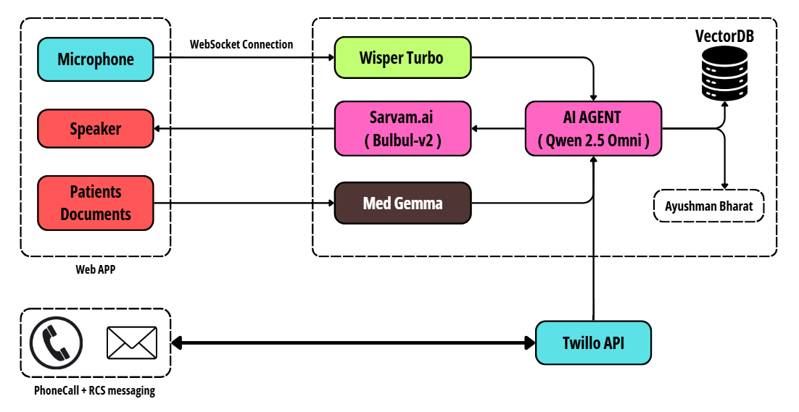

***Feasibility & Execution***

The project is built on **end-to-end LLM pipelining** using open-source models for voice, language, and document parsing. It operates via web and call-based systems, integrating **Twilio and Ayushman Bharat APIs** to ensure scalable, real-time healthcare access even in remote rural regions.

***Scalability & Impact***

The solution is highly scalable due to its **modular architecture** and use of **open-source, low-cost models**. It can be deployed across hospitals, clinics, and rural health centres with minimal infrastructure. By **automating documentation and enhancing data accessibility**, it improves care quality, reduces errors, and significantly enhances healthcare efficiency and communication across India’s diverse and underserved regions. The project also focuses on building a **modular AI agent with an ability to run on edge hardware** like android phones, iPhone and Personal PC’s.

***Conclusion / Summary & Bonus MVP***

A **pure voice** only solution that is need of the hour for the doctors and medical personals.

D-BOTT offers a **practical**, **scalable solution** using **open-source LLMs**, **voice agents** (Wisper Turbo, Sarvam.ai), **Med Gemma** for document parsing, and **Qwen 2.5 Omni** for AI reasoning. Integrated with Ayushman Bharat and Twilio API, it **supports rural outreach via voice and RCS**.

The MVP includes a **web app** with **voice-based consultation**, **real-time patient record** **summarization**, and **AI-assisted prescription support**. Expected impact includes **reduced doctor workload**, **faster diagnosis**, **better patient understanding**, and **improved continuity of care through centralized**, **interoperable health records**.